LIF101A – INTRODUCTION TO BIOLOGY

Sample question paper

Section I: Multiple choice questions (fill in the circle on the multiple choice form)

(Note: +0.5 for correct answer and -0.25 for incorrect answer)

1. If two pea plants having red (dominant) coloured flowers with unknown genotypes are crossed, 75% of the flowers are red and 25% are white. The genotypic constitution of the parents having red coloured flowers will be
a. both heterozygous
b. one homozygous and the other heterozygous
c. both homozygous
d. both hemizygous

2. A(n) ________is a piece of DNA with a group of genes that are transcribed together as a unit.

- promoter
- repressor
- operator
- operon

3. Which characteristic of the genetic code lowers the likelihood of mutation?

    - universality
    - degeneracy
    - triplet
    - non-overlapping nature

4. If an intestinal cell in a grasshopper contains 24 chromosomes, a grasshopper sperm cell
would contain ____ chromosomes.
- 3 c. 12
- 6 d. 24

5. The flow of genetic material in microbial cells usually proceeds from

- Proteins through RNA to DNA
- RNA through DNA to proteins
- DNA through RNA to proteins
- All the above

6. If a normal man marries a woman who is a carrier for a sex-linked recessive trait, where might

one expect to see the trait expressed in their children?

a. In all the children c. In half of the daughters

b. In all the sons d. In half the sons

7. Information in DNA is carried in __________.
  - the sugar-phosphate backbone of one DNA strand
  - the order of the nucleotide bases in DNA strand
  - the proteins that bind to the DNA double helix
  - all of the above

8. Why are UGA, UAG and UAA called termination codons?

a. They do not specify any amino acid

b. They are present at the beginning of mRNA

c. They terminate anti codons

d. They indicate initiation of translation

9. Which of the following correctly lists the items in order of their relative sizes?
  - nucleotide, codon, base pair, promoter, hemoglobin mRNA, hemoglobin gene, chromosome
  - nucleotide, base pair, codon, promoter, hemoglobin gene, hemoglobin mRNA, chromosome
  - nucleotide, base pair, codon, promoter, hemoglobin mRNA, hemoglobin gene, chromosome
  - none of the above

10. Bill has a round nose. Round noses are dominant. If Sally has a straight nose, what is her

genotype?
a. Nn c. Nn
b. NN d. nn

11. Rick's father has round ears, but his mother has point ears. Ricks grandfather had pointy ears,

which are recessive. Rick has round ears. What is his genotype?

a. round
b. pointy
c. EE
d. Ee

12. A nonsense mutation involves:
a. a regulatory sequence c. an AG splice acceptor site
b. the creation of a different amino acid d. the creation of a stop codon

13. In a diploid set of chromosomes, one of each pair of homologous chromosomes is derived from
the father (paternal), the other of each pair from the mother (maternal). If 2n= 8, what is the
probability of obtaining a gamete in which all the chromosomes are only from one the parent?

a. 1/4 c. 1/16
b. 1/8 d. 1/32
Explanation: Since 2n=8, n=4
There are 4 pairs of chromosomes. For each pair the probability of obtaining the chromosome from a single parent is 1/2. As there exist 4 such pairs the combined probability is 1/2x1/2x1/2x1/2=1/16.
14. The sequence of events mentioned below are symbolized by alphabets. Choose the correct answer where the alphabets are matched with the processes. (→)
RNA —(A)→ DNA —(B)→ DNA —(C)→ mRNA —(D)→ Polypeptide
a. | A = Replication, B = Transformation, C = Transcription, D = Translation
b. | A = Reverse transcription, B = Translation, C = Transcription, D = Replication
c. | A = Replication, B = Transcription, C = Translation, D = Transduction
d. | A = Reverse transcription, B = Replication, C = Transcription, D = Translation

15. In humans, the _____determines the sex of the offspring because __________.
- the sperm can fertilize either a female egg or a male egg
- Chromosome contribution from both parents --the offspring uses all the parents' chromosomes.
- only the female has two functional sex chromosomes
- the male can contribute either an X or a Y chromosome

16. Anticodon is the term applied to
  - the concept that multiple codons sometimes code for a single amino acid
  - the several three-nucleotide stretches that code for "stop"
  - the list of amino acids that corresponds to the genetic code
  - the part of the tRNA that interacts with the codon

17. Synthesis of a protein based on the sequence of messenger RNA

  - is catalyzed by RNA polymerase
  - is catalyzed by DNA polymerase
  - is called transcription
  - is called translation

18. Which one of the following is true about homologous chromosomes?
- They are found in animal cells but not in plant cells.
- They have genes for the same traits at the same loci.
- They pair up in prophase II.
- They are found in haploid cells.

19. When we say that an organism is haploid, we mean that _____.

- its cells each have one chromosome

- it has one half of a chromosome
- its cells each have one set of chromosomes
- its cells each have two set of chromosomes

20. It was important that Mendel chose true-breeding varieties for his experiments because
  - true-breeding varieties are ALWAYS heterozygous for the trait of interest
  - true-breeding varieties are NEVER heterozygous for the trait of interest
  - true-breeding varieties are more vigorous
  - true-breeding varieties are easier to cross-pollinate

21. In a certain plant, the alleles A, B, and C are completely dominant to the alleles a, b, and
c. A plant with the genotype AABbcc will have the same phenotype as the plant with the
genotype _____.

  - AAbbcc
  - aabbcc
  - AaBBcc
  - AABBCc

22. Phenylketonuria is an autosomal recessive disorder. Using "P" and "p" to represent the
alleles, what is the genotype of a phenylketonuric person?

  - PP
  - Pp
  - pp
  - Pp or pp

23. What would happen if in a gene encoding a polypeptide of 50 amino acids, 25th codon (UAU)
is mutated to UAA
a. a polypeptide of 24 amino acids will be formed
b. a polypeptide of 25 amino acids will be formed
c. a polypeptide of 49 amino acids will be formed
d. two polypeptides of 24 and 25 amino acids will be formed

24. An AABb individual is mated with another AABb individual. The possible numbers of
genetically different kinds of offspring are _____.

a. 1 c. 3
b. 2 d. 4

Explanation: AABb x AABb

Male/female Gametes | AB | Ab
Ab | AABb | AAbb
AB | AABB | AABb

25. If each parent can produce 100 genetically distinct gametes, how many genetically
distinct offspring can two parents produce?

a. 10,000 c. 1,000
b. 200 d. 100
Explanation:
As each parent can produce 100 genetically distinct gametes, both parents together can produce 100x100= 10,000 distinct offspring.

26. Color blindness is a recessive, X-linked trait in humans. If a color-blind woman marries a
man with normal vision, the female offspring will be ___, & the male offspring will be ___.

- color-blind ... normal
- carriers ... color-blind
- carriers ... normal
- normal .. normal

27. ____ results in recombination of genes.

a. Crossing over
b. Transcription
c. Duplication
d. none of these answers

28. Which one of the following is not a part of a transcription unit in DNA?
a. a promoter c. the inducer
b. the structural gene d. a terminator

29. A diploid cell contains two pairs of homologous chromosomes. Each pair is heterozygous for a pair of alleles, Aa and Bb respectively. After meiosis, how many different combinations of these alleles could be produced in the haploid daughter cells?

a. 2 c. 8
b. 4 d. 16
Explanation:
For the alleles Aa, either A or a could come so there are 2 ways possible. Similarly for Bb, either B or b could come so again there are two ways possible. So in total 2x2=4 ways are possible.

30. Meiosis is similar to mitosis in that

a. synapsis is a characteristic event.
b. spindle fibers control movement of chromosomes.
c. the daughter cells are identical.
d. haploid cells are produced.

31. The reason that sexually reproducing organisms produce offspring different from themselves is
a. crossing over.
b. random arrangement of chromosomes at the spindle equator.
c. fertilization is a chance mix of genetically different gametes.
d. all of these answers

32. How many different types of genetically different gametes will be produced by a heterozygous plant having the genotype AABbCc?
a. six c. two
b. nine d. four

Explanation:
All genes will assort independently. For gene A there is only one way possible, for gene B there are two ways possible (alternate alleles exist), for gene C there are two ways possible (alternate alleles exist). So, the gametes can be produced in 1x2x2=4 ways.

33. Which of the following statements is not one of Mendel’s tenets?
a. There are discrete units of inheritance called factors.
b. Organisms inherit two factors, one from each parent.
c. Different factors assort independently into gametes.
d. Characteristics of the parents blend together in their offspring.

34. The term phenotype refers to the __________ of an individual.

- Breeding pattern
- Number of chromosomes
- Genetic constitution
- Appearance of a characteristic or trait

35. Which of the following is a difference between mitosis and meiosis?
- Interphase is present only in mitosis.
- Homologous chromosomes associate only in meiosis.
- DNA replication occurs only in mitosis.
- Chromosomes line up on the cell equator only in meiosis.

36. Mendel’s law of segregation, as applied to the behavior of chromosomes in meiosis, means that:
- Pairing of homologs will convert one allele into the other, leading to separation of the types
- Alleles of a gene separate from each other when homologs separate in meiosis I or in meiosis II if there is a single crossover between the gene and the centromere
- Genes on the same chromosome will show 50% recombination
- Alleles of a gene will be linked and passed on together through meiosis

37. If the diploid number of chromosomes in a certain animal is 6 (2n = 6), there are three sets of
2 homologous chromosomes each, or three pairs. If there is no crossing over, how do these three
pairs align and separate in meiosis?
- All members of each set move together.
- Any 2 sister chromatids move together in Meiosis II
- The first to move influences all the others
- The align and assort independently to form any of eight different combinations

38. Alleles are ___________

a. Different molecular forms of a gene
b. Different phenotypes

c. self fertilizing, true breeding homozygotes
d. basic unit of heredity

39. A heterozygote has a ____ for the trait being studied

- pair of identical alleles
- pair of nonidentical alleles
- haploid condition, in genetic terms
- (a) and (c)

40. F1 offspring of the monohybrid cross AA X aa are

a. All AA
b. All Aa
c. All aa
d. ½ AA and ½ aa

41. Imagine that a codon in the template strand of a gene has the sequence TAC. What sequence of the anticodon would decode this codon?
  - AUG, because the anticodon is complementary to the template strand
  - ATG, because the anticodon is complementary to the template strand
  - UAC, because the anticodon has the same sequence as the template strand (but
it has U instead of T)
  - TAC, because the anticodon has the same sequence as the template strand

42. If one strand of DNA has the nitrogenous base sequence as ATCTG, what would be the complementary RNA strand sequence?

  - AACTG
  - ATCGU
  - TTAGU
  - UAGAC

43. Degeneracy of genetic code is due to
  - functional 61 codons and 20 amino acids
  - functional 64 codons and 20 amino acids
  - functional 20 codons and 20 amino acids
  - functional 20 codons and 61 amino acids

44. What is the promoter region?
  - It is a region of RNA that binds to the RNA polymerase and initiates transcription.
  - It is a region of a parent DNA strand that binds to the RNA polymerase & initiates transcription
  - It is a component of each type of RNA.
  - none of the above

45. Which of the statements below is false?

    - The genetic code is overlapping.
    - The genetic code is universal.
    - Degenerate codons specify the same amino acids
    - The genetic code is triplet.

46. If you were to create a drug that recognized and bound irreversibly to the promoter region of a
specific gene, thereby blocking it, what effect would you expect that drug to have?

  - There would be no effect on the gene.
  - Only transcription of that gene would halt.
  - Only translation of the gene would stop.

d. Both transcription and, eventually, translation of the gene would halt

47. Which of the mutations is likely to have the most dramatic effect on the protein coded for by that gene?

  - a base insertion near the end of the
coding sequence
  - a base insertion near the beginning of
the coding sequence
  - deletion of three bases near the start of
the coding sequence
  - a base substitution

48. During replication of DNA Okazaki fragments are formed in the direction of:

a. 3’->5’ c. 5’->3’
b. 3’->3’ d. 5’->5’

49. A DNA strand with the sequence AACGTAACG is transcribed. What is the sequence of
the mRNA molecule synthesized? The sequence below are written as 3’->5’

a. AACGTAACG c. AACGAACG
b. UUGCAUUGC d. TTGCATTGC

50. Which of the following is an example of the redundancy of the genetic code?
a. a given amino acid has more than one codon
b. each codon specifies more than one amino acid
c. the first two bases specify the amino acid
d. all the above

---------------------------End of Section I--------------------------------

Section II: Critical questions and Problems

1. Use the following words to complete the sentence below (fill in the space). 3 marks
dominant, homozygous, non-identical, heterozygous, identical
(There is no partial marking for this question all blanks must be correctly filled)

All non-reproductive cells contain two alleles of each gene. When those alleles are ___identical_____, the cell is said to be_____homozygous_____. When those alleles are __________non-identical_, the cell is said to be _____heterozygous_______, in which case the cell’s (or organism’s) phenotype is dictated by the ____dominant_________ allele.

2. Questions A-D: refer to the following genetics cross: 2 X 4=8 marks
Albinism is a condition that results from the lack of normal pigmentation. In humans, individuals with two recessive alleles, (aa) are albinos (thus allele A is dominant and non-albino). Attached earlobes result from two recessive alleles, (ee) (thus all E is dominant that causes non-attached earlobes). An albino man with attached earlobes marries a pigmented woman with non-attached earlobes. They have 8 children (the F1) none of them twins. All of their children are pigmented with non-attached earlobes.

A. What is the most likely genotype of the man?___________aaee________(write the genotype)

B. What set of alleles for earlobes and pigmentation do the women’s gametes carry?
_________AAEE_________(write the genotype of the gametes of the mother)

C. What is the genotype of their children?_____AaEe____(write the genotype(s) of the children)

D. What proportion of the gametes from the F1 progeny would be expected to carry recessive allele (a) for pigmentation and the dominant allele (E) for earlobes?
_________1/4 or 25%_________________(write the proportion in percentage or fraction)

3. A pedigree chart is shown on your right. Answer the following: (4 marks)
a. The trait is ________recessive____ (dominant / recessive) because

Justify your answer
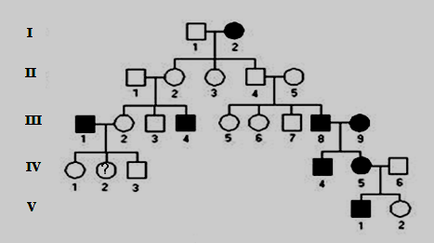
Justification:
Unaffected parents give rise to affected progeny:
II 1 X II 2 → III 4
II 4 X II 5 → III 8 ____________________________________________

b. The trait is ____autosomal_________ (autosomal / sex-linked) because Justify your answer
__________ Justification:
Not Y-linked as females are affected. Not X-linked, or affected mother would have all sons affected
But, I2 is affected while II4 is not. So, trait is autosomal.

4. In a diploid organism of genotype A/a ; B/b ; D/d, the allele pairs are all on different chromosome pairs. The following diagrams purport to show anaphases (“pulling apart” stages) in individual cells. A line represents a chromosome or a chromatid, and the dot indicates the position of the centromere.

State whether each drawing represents mitosis, meiosis I and meiosis II or is possible for this particular genotype. Indicate your answer in the box on the right side of each drawing. Assume no crossing over takes place.
4. A diploid organism has the genotype A/a ; B/b ; D/d. The alleles for each gene are present on different chromosome pairs. The following diagrams purport to show anaphases (“pulling apart” stages) in individual cells for this organism. A line represents a chromosome or a chromatid, and the dot indicates the position of the centromere. Assume no crossing over takes place.
Taking into account the above conditions, indicate which drawings are not possible (write impossible). For the possible cases indicate whether it represents mitosis, meiosis I or meiosis II. Indicate your answer in the box on the right side of each drawing. 10 marks

Possible/Impossible Possible/ Impossible
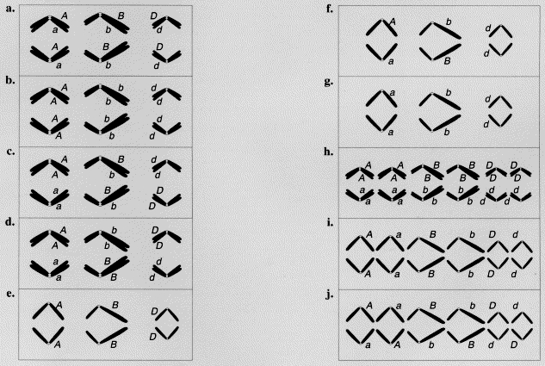
a. Meiosis I/ impossible
b. Meiosis I/ impossible

c. Meiosis I/ impossible
d. Meiosis i/ possible

e. Meiosis-II/ possible

f. Meiosis II/ impossible

g. Meiosis II/ possible
h. Meiosis I/ impossible
- i. Mitosis/possible

j. Mitosis/ impossible

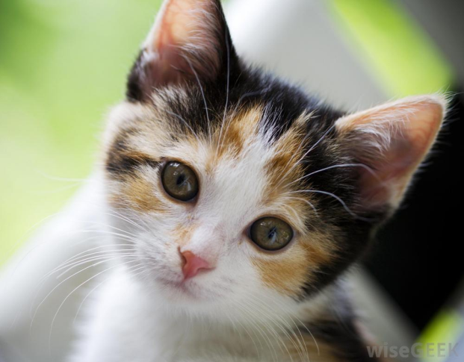
5. .The cat in the picture is heterozygous for Orange (B) and black (b) allele for fur coloration. Why is its fur coloration patchy? 5 marks
Because.-------- fur coloration gene lies on X- Chromosome and one X out of the two gets randomly inactivated in female mice during its development.
Section III: Critical questions
1. You would recall the graphical presentation of Griffith’s experiment shown here. Read the explanations provided below as a cause for the death of the mouse in the bottom row and then identify if the reason provided is true or false.

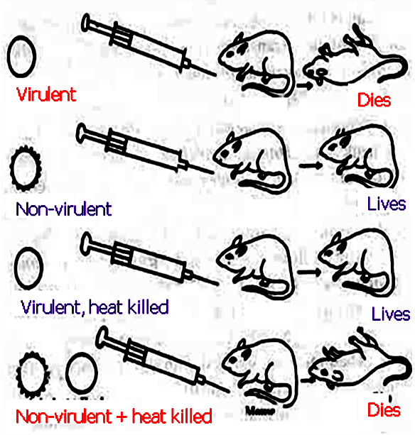
(2x5) 10 Marks
The mouse in the bottom row dies because;
a. It was injected with transforming factor from a virulent strain ______False____(True/False)

b. The injected bacterial strain remained non-virulent __False______True/False)

c. Although the injected bacterial strain was non-virulent, it became virulent due to uptake of
virulent transforming factor __________True__________(True/False)

d. The heat killing of the virulent strain was not successful___ False_______(True/False)

e. Bacterial strain as such is not important, the transforming factor of virulent
strain can kill the mouse. __False__________(True/False)
__________________________________________________

2. Fill in the blanks in the following table. You will need to consult a table of the genetic code (given on last page) to answer the question. Do not consider wobble base pairing in your answers. 6 marks

DNA double helix | 5’-  3’- | A  T | T  A | G  C | C  G | A  T | C  G | G  C | A  T | G  C | T  A | G  C | C  G | A  T | A  T | G  C | -3’  -5’
mRNA | 5’ | A | U | G | C | A | C | G | A | G | U | G | C | A | A | G | -3’
tRNA anti-codon | 3’ | U | A | C | G | U | G | C | U | C | A | C | G | U | U | C | -5’
amino acids | NH₂ | MET |  |  | HIS |  |  | GLU |  |  | CYS |  |  | LYS |  |  | COOH

3. A B
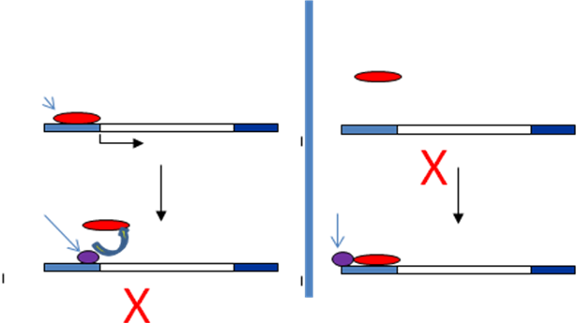
Two broad strategies for regulation of prokaryotic operons are shown in the cartoon above. Mark the components on the figure. Also identify the nature of the regulation involved Operon A and operon B. You will mark inside the cartoon.
(6 Marks)
___________________________________________________________________________

. 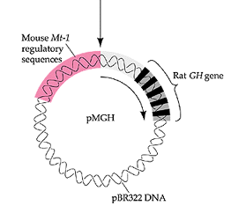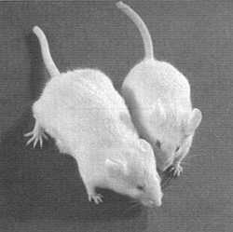
4. The cartoon above shows the recombinant DNA vector used to create transgenic mice.
- Explain the key components of the recombinant vector.

Regulatory element (Mouse Mt-1 sequence Metallothionein ), insert (transgene Rat GH growth hormone gene)

- Explain which of the two mice is likely to be the genetically muddied one & why?

The longer mice is likely to be the genetically modified one as the vector contained the Rat GH gene which is expressed due to the presence of Mt1 gene when the pups are raised in diet containing heavy metal 3X2 = 6 marks

5. For each of the polypeptide shown in the box identify the changes that has occurred at the DNA level of the codon: such as a base pair substitution, frame shift mutation, missense, nonsense etc( 2 x 6 = 12 marks)
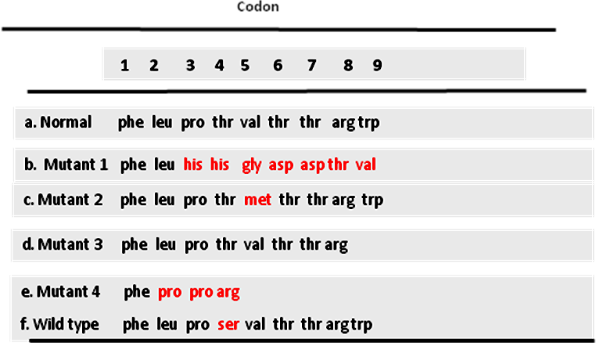

- ___Normal___
- Frameshift/insertion__
- Base pair substitution/missense
- base pair substitution/Non-sense
- _Frameshift/deletion/Non-sense
- _Base pair substitution/missense
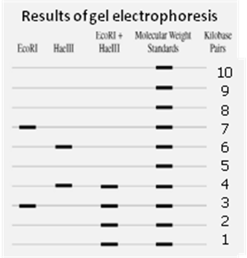
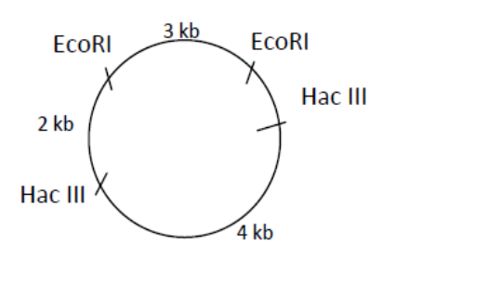

6. From the results of restriction digestion made on a plasmid DNA draw the restriction map of its circular chromosome. Place your answer/drawing on the space shown on sides of the image above.
(5 marks)

